Project Design Phase-II
Data Flow Diagram & User Stories
Date | 21 October 2026
Team ID | SWUID2026403023
Team Members | Individual project (single member)
Project Name | StaffSync
Maximum Marks
Document Version | v1.2 (revised 27 October 2026; originally issued 21 October 2026 as v1.0)

Data Flow Diagrams:
A Data Flow Diagram (DFD) illustrates how HR, Managers and Employees use StaffSync and how information flows through the React interface, Express REST API and MongoDB data layer. The key workflows are employee management, leave management, attendance, announcements and training.
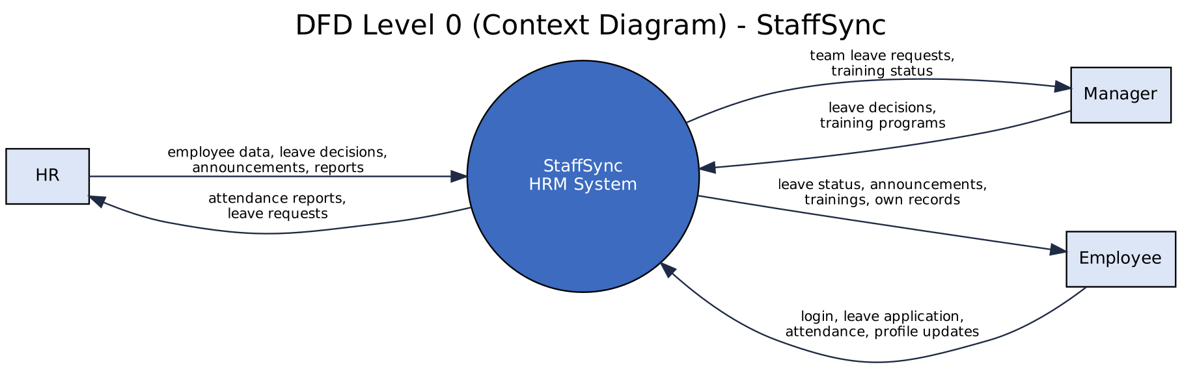
Figure 1: DFD Level 0 (context diagram)
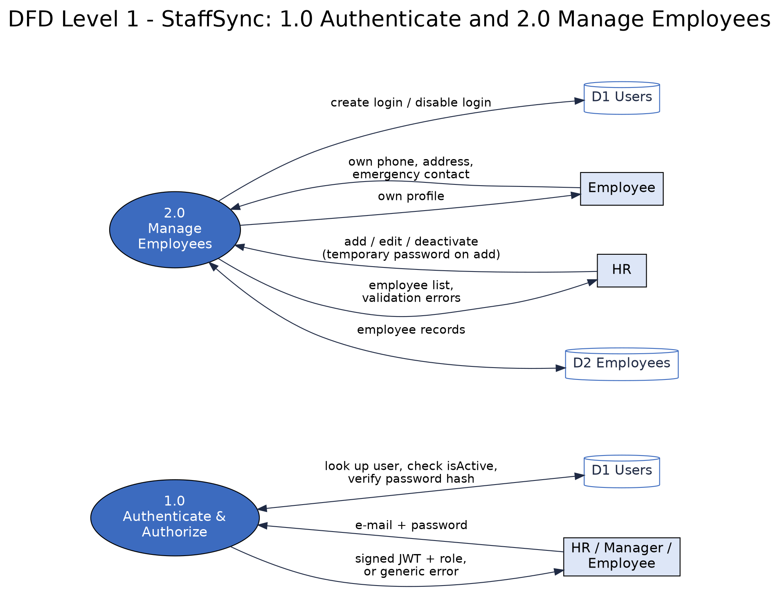
Figure 2a: DFD Level 1 - processes 1.0 and 2.0
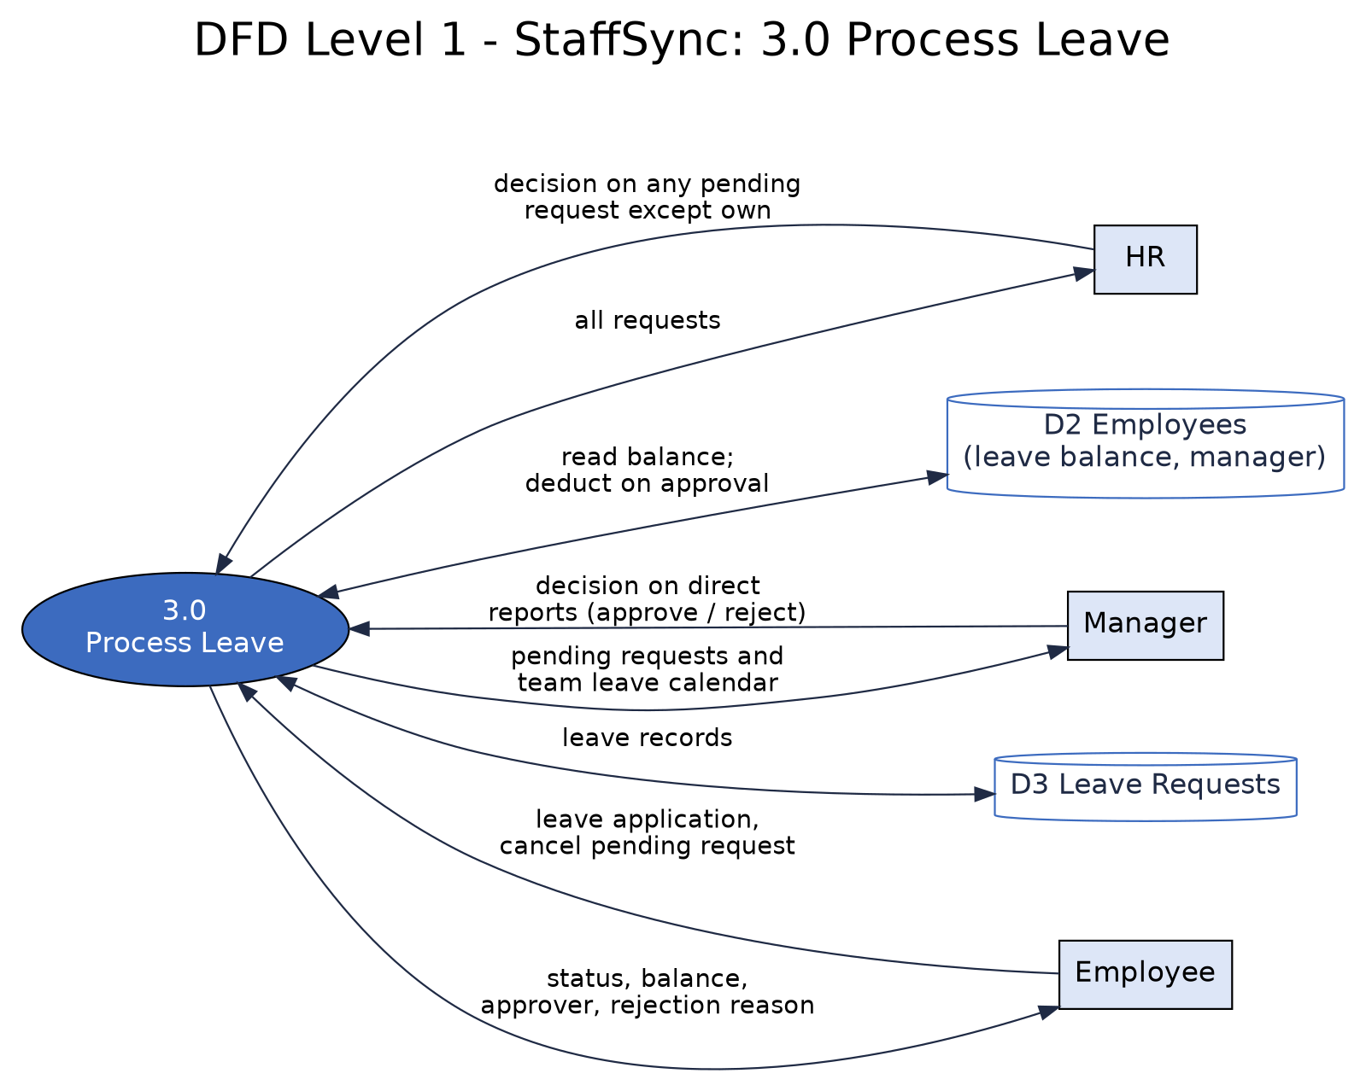
Figure 2b: DFD Level 1 - process 3.0
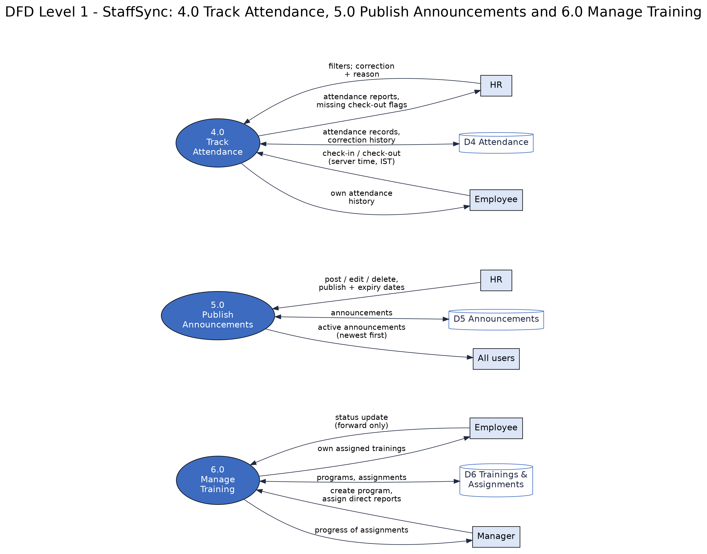
Figure 2c: DFD Level 1 - processes 4.0, 5.0 and 6.0
User Stories
User Story Table - StaffSync
USN | User type | Epic | User story / task | Acceptance criteria | Priority | Sprint | Requirements
USN-1 | Developer | Project Setup & Authentication | As a developer, I set up the MERN project structure, environment variables (.env.example), MongoDB connection and the HR seed script. | Server starts and connects to Atlas; .env is git-ignored; .env.example lists every variable; the seed script creates two HR accounts. | High | Sprint-1 | FR-1.7, NFR-2, NFR-9
USN-2 | All users | Project Setup & Authentication | As a user, I can log in with e-mail and password, log out and change my password; a new user must change the temporary password at first login. | Valid login returns a JWT and opens the role dashboard; invalid login shows a generic error; an expired token redirects to login; logout clears the token; a new password has 8+ characters with a letter and a digit. | High | Sprint-1 | FR-1.1, 1.2, 1.3, 1.5, 1.6, 1.7
USN-3 | All users | Project Setup & Authentication | As a user, I can only access pages and APIs permitted for my role. | An Employee calling an HR-only endpoint gets 403; role and active status are read from the database on every request; the UI hides unauthorized menus but is never the only protection. | High | Sprint-1 | FR-1.4
USN-4 | HR | Employee Management | As HR, I can add, edit, view, search and deactivate employee records (no permanent deletion). | Required fields are enforced; a duplicate employee ID or e-mail returns 409; the employee ID cannot be changed; deactivation disables login but keeps history; the list is searchable and paginated. | High | Sprint-1 | FR-2.1, 2.2, 2.3, 2.5
USN-5 | Employee | Employee Management | As an employee, I can view and update my personal details. | Only phone, address and emergency contact are editable; other fields and other employees' records are refused (403). | Medium | Sprint-1 | FR-2.4
USN-6 | Employee | Leave Management | As an employee, I can apply for leave (validated dates, no overlaps, balance check), cancel a pending request and see my history, balance and status. | End date is not before start date; start date is not in the past (Sick leave may be backdated up to 7 days); no overlap with Pending or Approved leave; paid days fit the balance; weekends are not counted; saved as Pending; the owner may cancel while Pending. | High | Sprint-2 | FR-3.1, 3.2, 3.6
USN-7 | Manager | Leave Management | As a manager, I can approve or reject my direct reports' leave requests (not my own) and view my team's leave calendar. | A manager decides only direct reports' requests; a rejection needs a reason; a decided request cannot be changed (409); a second concurrent decision is refused; the calendar shows Pending and Approved leave of direct reports. | High | Sprint-2 | FR-3.3, 3.4, 3.5, 3.7
USN-8 | HR | Leave Management | As HR, I can view all leave requests and approve or reject any pending one except my own. | HR decides any pending request, including managers'; an HR user's own request is decided by another HR user; decidedBy and decidedAt are stored; the balance is deducted on approval. | High | Sprint-2 | FR-3.3, 3.4, 3.5
USN-9 | Employee | Attendance Management | As an employee, I can check in and out once per day; duplicates are blocked. | Server time (IST) is used; a second check-in returns 409; check-out needs a check-in and must be later; a day without check-out is flagged 'Missing check-out'. | High | Sprint-2 | FR-4.1 to 4.4
USN-10 | Employee | Attendance Management | As an employee, I can view my attendance history. | History shows date, check-in, check-out and status for the logged-in employee only. | Medium | Sprint-2 | FR-4.6
USN-11 | HR | Attendance Management | As HR, I can view attendance of all employees, filter by date and employee, and correct a record with a reason. | Filters work; a correction needs a reason and stores correctedBy and the previous values. | Medium | Sprint-3 | FR-4.5, 4.6
USN-12 | HR | Announcements & News | As HR, I can post, edit and delete announcements with publish and expiry dates. | Title and body are required; an edited item shows 'Edited'; delete removes it for everyone. | High | Sprint-3 | FR-5.1, 5.2
USN-13 | All users | Announcements & News | As a user, I can view the latest announcements and news. | Only active announcements (between publish and expiry date) are shown, newest first. | Medium | Sprint-3 | FR-5.3
USN-14 | Manager | Training & Development | As a manager, I can create training programs with a deadline, assign them to my direct reports and track progress. | Title, description and deadline are required; only direct reports can be assigned; each assignment starts as Not Started; the manager sees the status of every assignment created. | High | Sprint-3 | FR-6.1, 6.4
USN-15 | Employee | Training & Development | As an employee, I can view my assigned trainings and move their status (Not Started, In Progress, Completed). | Only my own assignments are listed with deadline; status moves forward only; overdue items are flagged. | Medium | Sprint-4 | FR-6.2, 6.3
USN-16 | All users | Frontend Dashboards | As a user, I see a role-based dashboard with a responsive Bootstrap UI. | The dashboard shows only the role's menu and widgets; the layout works from 360 px width to desktop. | High | Sprint-4 | NFR-1, NFR-10
USN-17 | All users | Frontend Dashboards | As a user, I get clear validation messages and error handling on all forms. | Field-level messages for invalid input; server errors show a generic message; no stack traces are shown. | Medium | Sprint-4 | FR-2.1, FR-3.1, NFR-3
USN-18 | Developer | Project Execution | As a developer, I test all APIs in Postman and prepare the UAT accounts, test data and test cases. | The Postman collection covers every endpoint in the API table; UAT accounts and data are ready; UAT execution follows in the 15-20 November UAT window. | High | Sprint-4 | All FR and NFR
USN-19 | Developer | Project Execution | As a developer, I deploy the app and publish the demo and GitHub links. | The deployed URL and repository link open correctly and are verified before being added to the documents. | High | Sprint-4 | NFR-2, NFR-5

Data Flow Diagram Notes
Figure 1 is the Level 0 (context) diagram: StaffSync as one process with the three external entities HR, Manager and Employee. Figures 2a to 2c are the Level 1 diagram, split over three pages for readability: six processes and six data stores (D1 to D6). Every flow is labelled, and each process shows both the data it receives from external entities and the data it returns to them. D6 holds two collections (trainings and trainingassignments).
Data Stores
Store | MongoDB collection(s) | Contents
D1 Users | users | Login e-mail, bcrypt password hash, role, link to employee, active flag, must-change-password flag
D2 Employees | employees | Employee ID, profile, department, designation, manager, status, leave balance
D3 Leave Requests | leaverequests | Leave requests, status, approver, decision time, rejection reason
D4 Attendance | attendances | Date, check-in, check-out, corrections and their history
D5 Announcements | announcements | Title, body, author, publish and expiry dates
D6 Trainings | trainings, trainingassignments | Programs and each employee's assignment status

Level 1 Data Flows
Flow | From | To | Data
Credentials | Employee, Manager, HR | 1.0 Authenticate | E-mail and password
Token or error | 1.0 Authenticate | Employee, Manager, HR | Signed JWT and role, or a generic error message
User lookup | 1.0 Authenticate | D1 Users (both ways) | Password-hash check, isActive and mustChangePassword flags
Employee data | HR | 2.0 Manage Employees | New, edited or deactivated employee records; temporary password
Employee list, errors | 2.0 Manage Employees | HR | Employee list (paginated), validation errors
Own profile update | Employee | 2.0 Manage Employees | Phone, address, emergency contact
Own profile | 2.0 Manage Employees | Employee | The employee's own record
Employee and login records | 2.0 Manage Employees | D2 Employees, D1 Users | Records; create or disable the login
Leave application | Employee | 3.0 Process Leave | Type, dates, reason; cancel of a Pending request
Leave status | 3.0 Process Leave | Employee | Status, balance, approver, rejection reason
Leave decision | Manager, HR | 3.0 Process Leave | Approve or reject, with a reason when rejecting
Pending requests, team calendar | 3.0 Process Leave | Manager, HR | Requests awaiting a decision; team leave calendar
Leave records and balance | 3.0 Process Leave | D3 Leave Requests, D2 Employees | Leave records; balance read and deducted on approval
Check-in / check-out | Employee | 4.0 Track Attendance | Request only; the server records the time (IST)
Attendance history | 4.0 Track Attendance | Employee | Own attendance records
Filters and corrections | HR | 4.0 Track Attendance | Date and employee filters; correction with a reason
Attendance reports | 4.0 Track Attendance | HR | Reports; 'Missing check-out' flags
Attendance records | 4.0 Track Attendance | D4 Attendance (both ways) | Records and correction history
Announcement | HR | 5.0 Publish Announcements | Title, body, publish and expiry dates
Active announcements | 5.0 Publish Announcements | All users | Announcements between publish and expiry date, newest first
Announcement records | 5.0 Publish Announcements | D5 Announcements (both ways) | Stored announcements
Training program | Manager | 6.0 Manage Training | Program, deadline and assigned direct reports
Training progress | 6.0 Manage Training | Manager | Status of every assignment created
Training status update | Employee | 6.0 Manage Training | Status change (forward only)
Assigned trainings | 6.0 Manage Training | Employee | The employee's own assignments with deadline and status
Training records | 6.0 Manage Training | D6 Trainings (both ways) | Programs and assignments

Requirement Traceability
Each story in the User Story Table above lists its requirement IDs (FR / NFR). The full mapping from user story (USN-1 to USN-19) to requirements and UAT test cases (TC-001 to TC-044) is the Requirements Traceability Matrix in the Solution Requirements document.
Revision History
Version | Date | Summary of changes
v1.0 | 21 October 2026 | Initial issue.
v1.1 | 23 October 2026 | Level 1 DFD redrawn (inputs and outputs for every process); user story table now lists all 19 stories with requirement IDs; flow table expanded; dangling traceability sentence fixed.
v1.2 | 27 October 2026 | Aligned the project overview and role/module descriptions with the current StaffSync stack and demo deployment; retained detailed design notes and planned-vs-actual distinctions.

